

CIS C290

M08 Assignment

Data Science Project

Chia-Sheng Wang

August 3, 2025

Dr. Aeron Zentner

Introduction – Purpose of the Report
This analysis seeks to build classification models for predicting a student’s rate of dropout and academic success. This study aims to build robust classification models to predict student dropout and academic success. With such predictions, the school counselors and instructors can further support students depending on the areas of struggle the student is facing based on the classification result.

Data Details

The data is created from a higher education institution, along with several disjoint databases, related to students enrolled in different undergraduate degrees. The data included 34 features acquired at the time of student enrollment, such as marital status, application mode, nationality, etc. The data included 4424 instances.

Analysis Techniques

Firstly, descriptive statistics are utilized to have a basic understanding of the data being used, which includes statistical values such as mean, median, standard deviation, etc. Next is the classification decision tree which models a tree-like structure based on the data. Classification decision tree is helpful to help us understand what variables an impacting variable to the student’s success.

Lastly, the support vector machine is utilized for improving the generalization and reducing overfitting of future models. This technique identifies the optimal hyperplane that separates datapoints into distinct classes, which is suitable for datasets like this where the number of independent variables is 34.

Results

According to the descriptive analysis, the marital status seems highly skewed, the application mode and order seems more balanced behavior indicated by the high standard variation. The classification decision tree indicated decent predictability on dropout and graduation, but bad precision on enrolled. This may be due to support on enrollment is relatively low compared to dropout and graduate variables. Overall, the accuracy of the classification decision tree is around 67.46%.
Lastly, the support vector machine suggests that the graduate and dropout accuracy is precise but not so much with enrollment, which aligns with what the classification decision tree suggests. This may be due to the lack of support to enrolled variable compared to dropout and graduate. This can be improved by more balanced data collection or just simply more data collected for analysis.
Descriptive Analysis
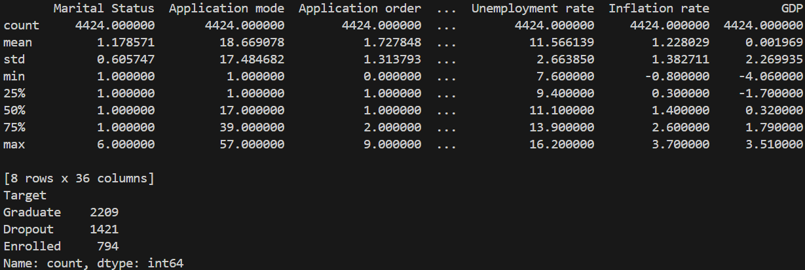
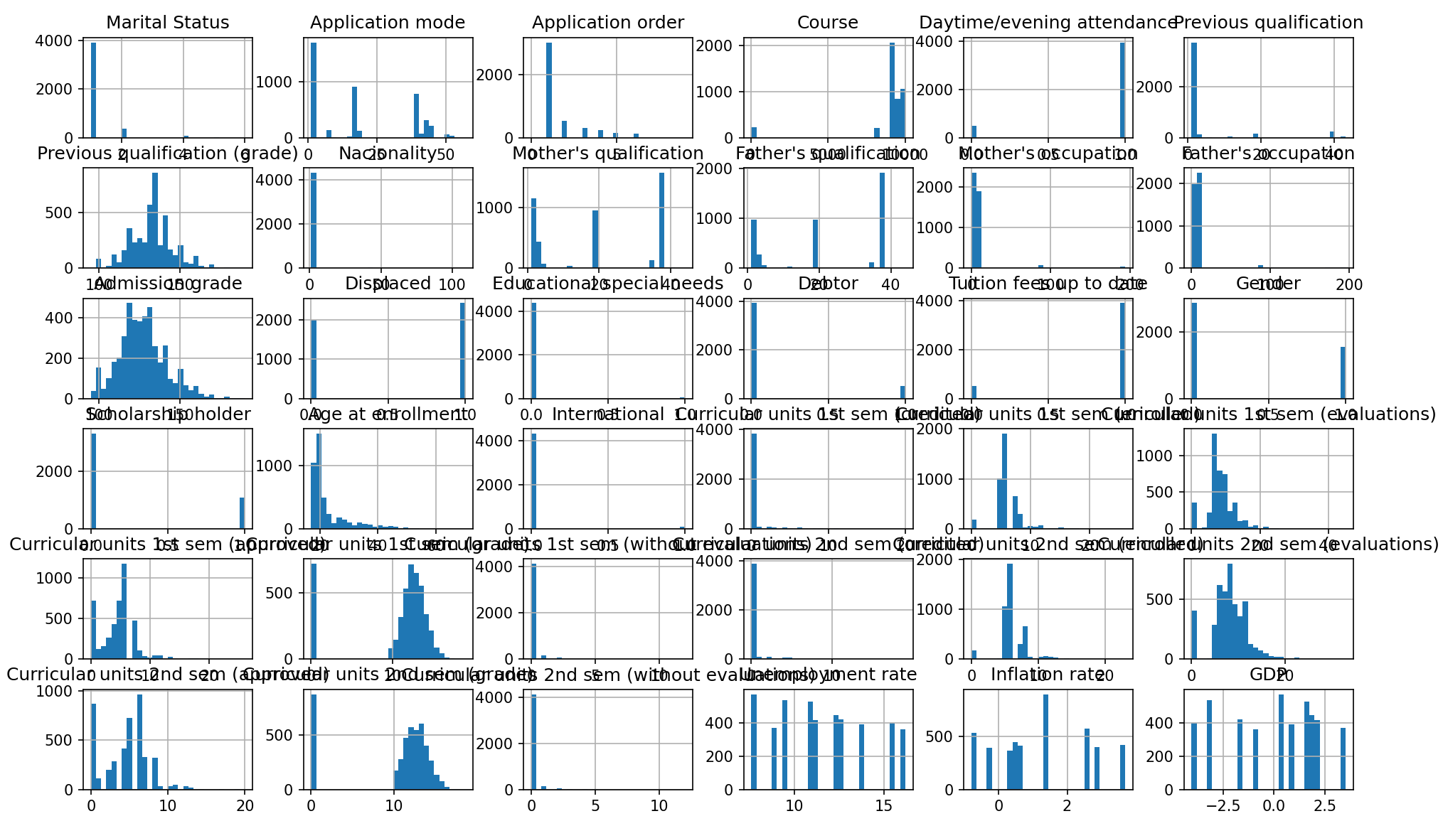
Classification Decision Tree
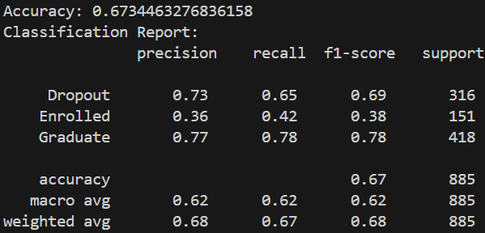
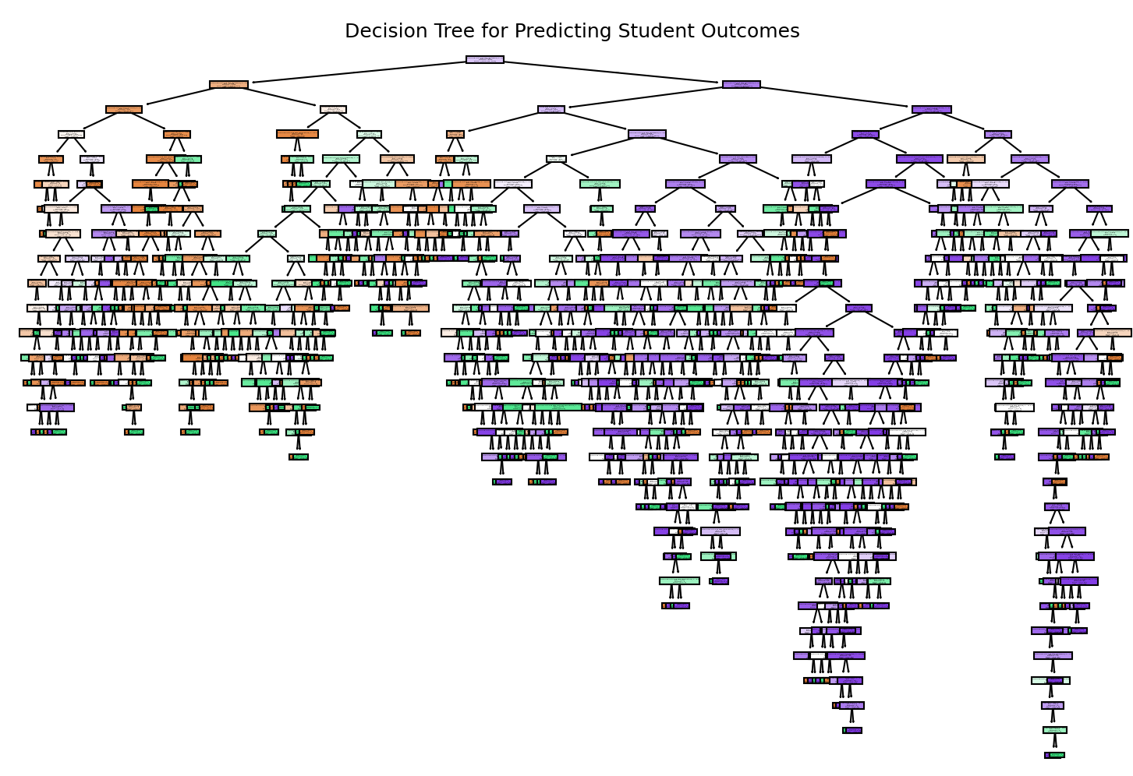

Support Vector Machine
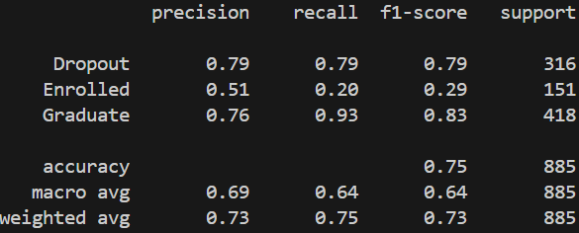
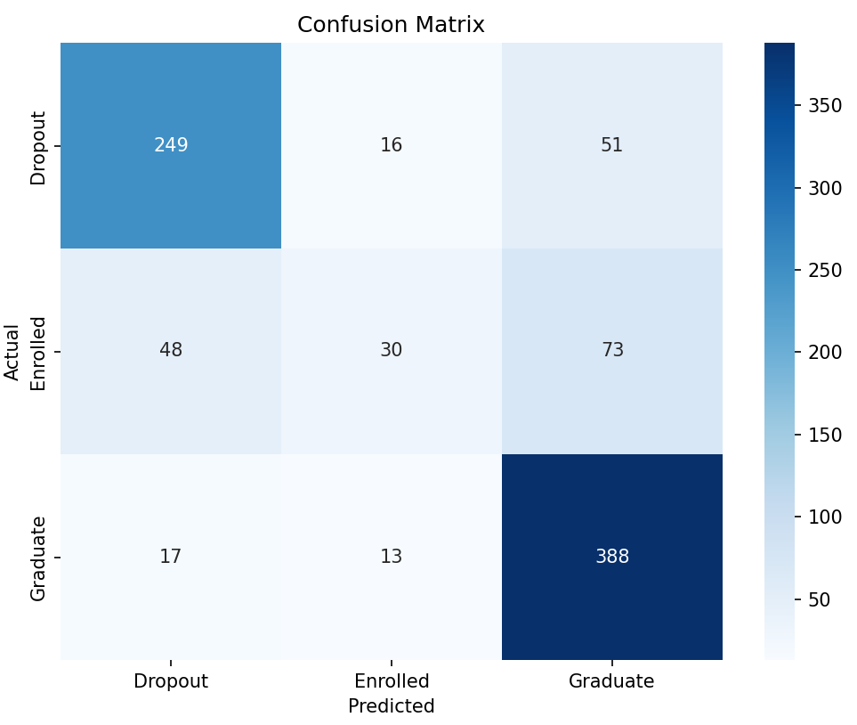

Appendix

Classification Decision Tree
from ucimlrepo import fetch_ucirepo
import numpy as np
from sklearn.model_selection import train_test_split
from sklearn.tree import DecisionTreeClassifier, plot_tree
from sklearn.metrics import accuracy_score, classification_report
import matplotlib.pyplot as plt

# Classification Decision Tree
# fetch dataset
predict_students_dropout_and_academic_success = fetch_ucirepo(id=697)

# data (as pandas dataframes)
X = predict_students_dropout_and_academic_success.data.features
y = predict_students_dropout_and_academic_success.data.targets

# split data into train and test sets
X_train, X_test, y_train, y_test = train_test_split(X, y, test_size=0.2, random_state=42)

# create decision tree classifier
clf = DecisionTreeClassifier()
clf.fit(X_train, y_train)

# make predictions
y_pred = clf.predict(X_test)

# evaluate classifier
print("Accuracy:", accuracy_score(y_test, y_pred))
print("Classification Report:\n", classification_report(y_test, y_pred))

# visualize decision tree
plt.figure(figsize=(12,8))
plot_tree(clf, feature_names=X.columns, class_names=np.unique(y), filled=True)
class_names = np.unique(y)
plt.title("Decision Tree for Predicting Student Outcomes")
plt.show()

Correlation Analysis
from ucimlrepo import fetch_ucirepo
import numpy as np
from sklearn.model_selection import train_test_split
from sklearn.svm import SVC
from sklearn.metrics import classification_report, confusion_matrix
import matplotlib.pyplot as plt
import seaborn as sns

# Support Vector Machine
# fetch dataset
predict_students_dropout_and_academic_success = fetch_ucirepo(id=697)

# data (as pandas dataframes)
X = predict_students_dropout_and_academic_success.data.features
y = predict_students_dropout_and_academic_success.data.targets

# split data into train and test sets
X_train, X_test, y_train, y_test = train_test_split(X, y, test_size=0.2, random_state=42)

# Train the SVM model
svm_model = SVC(kernel='linear') # You can experiment with different kernels
svm_model.fit(X_train, y_train)

# Make predictions
y_pred = svm_model.predict(X_test)

# Model evaluation
print(classification_report(y_test, y_pred))

# Confusion Matrix
cm = confusion_matrix(y_test, y_pred)
plt.figure(figsize=(8, 6))
sns.heatmap(cm, annot=True, fmt='d', cmap='Blues',
xticklabels=svm_model.classes_, yticklabels=svm_model.classes_)
plt.xlabel('Predicted')
plt.ylabel('Actual')
plt.title('Confusion Matrix')
plt.show()

